**Cruise Passenger Information Proposal**

**Project description**

The cruise passenger management system is used to manage passenger booking information and match it with the corresponding cruise ship. This system allows you to add, delete, and modify the corresponding passenger information, and the information of the booked cruise.

The system will use MySQL to process the data.

**Domain**

This system will be focusing on the data collection and search. Using different passengers’ information to set up a complete database system.

The domain in our system in the below:

The different cruises information.

The different ship information

The different passenger information(including name, phone number, travel details)

The manifest information(cruise, cabin, ship, passenger).

**Functionality**

In our system, we allow to insert, delete, modify passengers’ information and travel details.

1. Passenger: we have passengers’ information.
2. We have manifest record which list passengers will travel which cruise.
3. We have different cabins for passengers with different needs.

Our system is used to store passenger travel details.

**platforms**

For database system, I will use MySQL to develop.

**E/R Diagram**

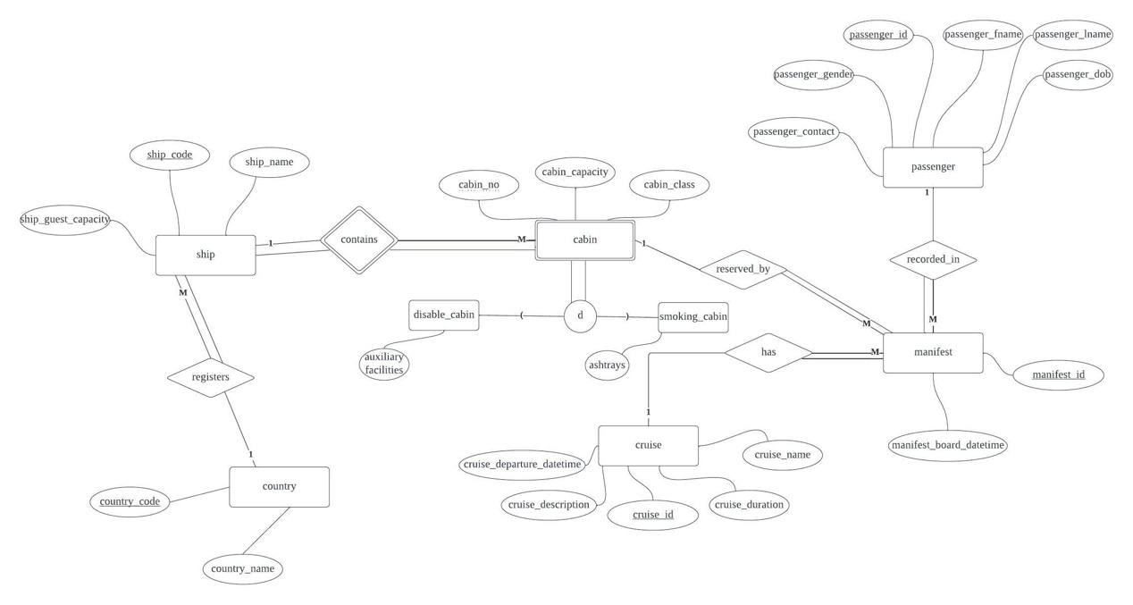



**Schema**

**Below is the schema for project:**

TABLE passenger (

passenger_id NUMBER(6) NOT NULL,

passenger_fname VARCHAR2(30),

passenger_lname VARCHAR2(30),

passenger_dob DATE NOT NULL,

passenger_gender CHAR(1) NOT NULL,

passenger_contact CHAR(10)

PRIMARY KEY(passenger_id)

)

CONSTRAINT chk_passenger_gender CHECK ( passenger_gender IN ( 'M', 'F', 'X' ) )

TABLE recorded_in(

passenger_id NUMBER(6) NOT NULL,

manifest_id NUMBER(7) NOT NULL

PRIMARY KEY(passenger_id, manifest_id)

)

TABLE manifest(

manifest_id NUMBER(7) NOT NULL,

passenger_id NUMBER(6) NOT NULL,

cruise_id NUMBER(6) NOT NULL,

cabin_no NUMBER(5) NOT NULL,

ship_code NUMBER(4) NOT NULL,

manifest_board_datetime DATE

PRIMARY KEY(manifest_id)

passenger.passenger_id -> manifest_passenger_id

cruise.cruise_id->manifest_cruise_id

cabin.ship_code->manifest_ship_code

cabin.cabin_no->manifest_cabin_no

)

CONSTRAINT manifest_un UNIQUE ( passenger_id, cruise_id )

TABLE has(

manifest_id NUMBER(7) NOT NULL,

cruise_id NUMBER(6) NOT NULL

PRIMARY KEY(manifest_id, cruise_id)

)

TABLE cruise(

cruise_id NUMBER(6) NOT NULL,

cruise_name VARCHAR2(80) NOT NULL,

cruise_description VARCHAR2(200) NOT NULL,

cruise_departure_datetime DATE NOT NULL,

cruise_duration NUMBER(2) NOT NULL,

ship_code NUMBER(4) NOT NULL

PRIMARY KEY(cruise_id)

ship.ship_code->cruise_ship_code

)

TABLE reserved_by(

cruise_id NUMBER(6) NOT NULL,

cabin_no NUMBER(5) NOT NULL,

PRIMARY KEY(cruise_id, cabin_no)

)

TABLE cabin(

ship_code NUMBER(4) NOT NULL,

cabin_no NUMBER(5) NOT NULL,

cabin_capacity NUMBER(1) NOT NULL,

cabin_class CHAR(1) NOT NULL

PRIMARY KEY(ship_code, cabin_no)

ship.ship_code->cabin_ship_code

)

CONSTRAINT cabin_class_chk CHECK ( cabin_class IN ( 'B', 'F', 'T', 'S' ) )

TABLE disable_cabin(

ship_code NUMBER(4) NOT NULL,

cabin_no NUMBER(5) NOT NULL,

auxiliary_facilities CHAR(1)NOT NULL

PRIMARY KEY(ship_code, cabin_no)

ship.ship_code->cabin_ship_code

)

CONSTRAINT chk_auxiliary_facilities CHECK ( auxiliary_facilities IN ( 'Y', 'N', 'U' ) )

TABLE smoking_cabin(

ship_code NUMBER(4) NOT NULL,

cabin_no NUMBER(5) NOT NULL,

ashtrays CHAR(1)NOT NULL

PRIMARY KEY(ship_code, cabin_no)

ship.ship_code->cabin_ship_code

)

CONSTRAINT chk_ashtrays CHECK ( ashtrays IN ( 'Y', 'N', 'U' ) )

TABLE contains(

ship_code NUMBER(4) NOT NULL,

cabin_no NUMBER(5) NOT NULL,

PRIMARY KEY(ship_code, cabin_no)

)

TABLE ship(

ship_code NUMBER(4) NOT NULL,

ship_name VARCHAR2(20) NOT NULL,

ship_guest_capacity NUMBER(4) NOT NULL,

country_code CHAR(2) NOT NULL

PRIMARY KEY(ship_code)

counrty.country_code->ship_country_code

)

TABLE sails(

ship_code NUMBER(4) NOT NULL,

cruise_id NUMBER(6) NOT NULL

PRIMARY KEY(ship_code, cruise_id)

)

TABLE country(

country_code CHAR (2),

country_name VARCHAR2 (40)

PRIMARY KEY(country_code)

)

TABLE registers(

country_code CHAR (2),

ship_code NUMBER(4) NOT NULL

PRIMARY KEY(country_code, ship_code)

)

**Functional Dependencies**

passenger(passenger_id, passenger_fname, passenger_lname, passenger_dob, passenger_gender, passenger_contact)

FD:

passenger_id-> passenger_fname, passenger_lname, passenger_dob, passenger_gender, passenger_contact

For this FD, passenger_id as primary key can map to other attributes uniquely.

manifest(manifest_id, passenger_id, cruise_id, manifest_board_datetime, ship_code, cabin_no)

FD:

manifest_id -> passenger_id, cruise_id, manifest_board_datetime, ship_code, cabin_no

For this FD, manifest_id as primary key can map to other attributes uniquely.

cabin(cabin_no, ship_code, cabin_capacity, cabin_class)

FD:

cabin_no, ship_code -> cabin_capacity, cabin_class

For this FD, cabin_no and ship_code combine can determine cabin_capacity, cabin_class. Because in different ship the cabin number maybe same, so need use the two together.

disable_cabin(cabin_no, ship_code, auxiliary_facilities)

FD:

cabin_no, ship_code -> auxiliary_facilities

For this FD, For this FD, cabin_no and ship_code combine can determine auxiliary_facilities.

smoking_cabin(cabin_no, ship_code, ashtrays)

FD:

cabin_no, ship_code -> ashtrays

For this FD, For this FD, cabin_no and ship_code combine can determine ashtrays.

cruise(cruise_id, cruise_name, cruise_description, ship_code, cruise_depature_datetime, cruise_duration)

FD:

cruise_id -> cruise_name, cruise_description, ship_code, cruise_depature_datetime, cruise_duration

For this FD, cruise_id can determine cruise_name, cruise_description, ship_code, cruise_depature_datetime, cruise_duration

ship(ship_code, ship_name, ship_guest_capacity, country_code)

FD:

ship_code -> ship_name, ship_guest_capacity, country_code

For this FD, ship_code can determine ship_name, ship_guest_capacity, country_code

country(country_code, country_name)

FD:

country_code -> country_name

For this FD, country_code can determine country_name

**NORMALIZATION**

